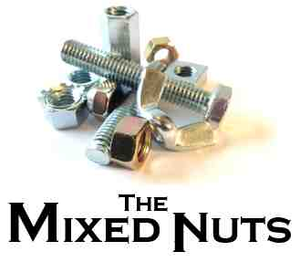
Christmas Party Songs - 2017
CP01-It's The Holiday Season(KVF).pdf
CP02-Sleigh Ride(KVF).pdf
CP03-Christmas Waltz, The(KVF).pdf
CP04-Jingle Bells(KVD).pdf
CP05-Have Yourself A Merry Little Christmas(KVF).pdf
CP06-Hang Up Your Stocking(KVD).pdf
CP07-Santa, Baby(KV).pdf
CP08-Winter Wonderland(KVF).pdf
CP09-Christmastime Is Here(Keyboard Female Chords).pdf
CP09-Christmastime Is Here(Keyboard Female).pdf
CP09-Christmastime Is Here(KVF).pdf
CP10-Feliz Navidad(KVF).pdf
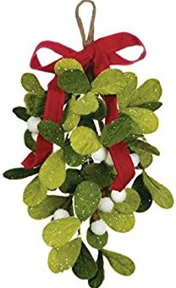
CP11-White Christmas(KVF).pdf
CP12-Most Wonderful Time Of The Year(KVF).pdf
CP13-Silver Bells(KVF).pdf
CP14-We Need A Little Christmas(KVF).pdf
CP15-Christmas Song (KVF).pdf
CP16-Rockin' Around The Christmas Tree (KVF).pdf
CP17-I'll Be Home For Christmas(KVF).pdf
CP18-Jolly Old St. Nick(KVF).pdf
CP19-Merry Christmas, Darling(KVF).pdf
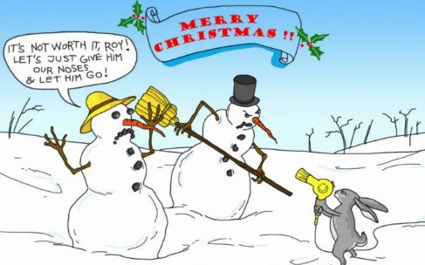
CP20-The Man With The Bag(KVF).pdf

